### Abstract: 147

# **Bioinspired Design of Highly Wet-Adhesive and Elastic Photocrosslinkable Recombinant Human Protein Networks for Surgical Applications**

*Anna Resch1, Matthias C. Huber1,2,3,* Alexander Resch4,* Andreas Schreiber1,2, Thabo Lapp4, Uwe Jonas,1 Adrianna Kolberg5, Sandra Haas6, Mathaeus Tschaikowsky5,8, Jürgen Hubbuch6, Daniel Böhringer7, Thomas Reinhard7, Bernd Rolauffs8, Bizan N. Balzer3,5, Günther Schlunck7 & Stefan M. Schiller1,3,8,9,10 (*equally contributing authors)*

1Center for Biological Systems Analysis, University of Freiburg, Habsburgerstrasse 49, 79104 Freiburg, Germany

2Faculty of Biology, University of Freiburg, Schänzlestrasse 1, 79104 Freiburg, Germany

3Cluster of Excellence livMatS @ FIT, Freiburg Center for Interactive Materials and Bioinspired Technologies, University of Freiburg, Georges-Köhler-Allee 105, 79110 Freiburg, Germany

4Chair for Information Systems Research, University of Freiburg, Platz der Alten Synagoge, 79098 Freiburg, Germany

5Institute of Physical Chemistry, Albertstrasse 21, University of Freiburg, 79104 Freiburg

6Karlsruhe Institute of Technology, Institute of Functional Interfaces & Institute of Engineering in Life Sciences, Section IV: Molecular Separation Engineering, Karlsruhe Institute of Technology, Fritz-Haber-Weg 2, 76131 Karlsruhe, Germany

7Eye Center, Medical Center, Faculty of Medicine, University of Freiburg, 79110 Freiburg, Germany

8G.E.R.N. Research Center for Tissue Replacement, Regeneration & Neogenesis, Department of Orthopedics and Trauma Surgery, Medical Center - University of Freiburg, Faculty of Medicine, University of Freiburg, Germany

9BIOSS Centre for Biological Signalling Studies, University of Freiburg, Schänzlestrasse 18, 79104 Freiburg, Germany

10IMTEK Department of Microsystems Engineering, University of Freiburg, Georges-Köhler-Allee 103, 79110 Freiburg, Germany

# Abstract

Nature utilizes protein-based high performance materials with remarkable mechanical and biological properties such as silk, resilin, and elastin, outperforming most synthetic materials. Here, we present the specially designed high-performance *BioUltraBond* protein-network utilizing a combination of physical and chemical network formation. We employ a fusion protein based on a human tetramer-forming ubiquitin-like domain (ULD), bisfunctionally linked to a highly elastic intrinsically disordered human elastin-like protein (ELP), while the ELP-linker is exchangeable with other linker proteins. Photochemical network formation employing various photocatalysts allows for tight control of material properties of this highly adhesive protein network. The strong adhesiveness and biocompatibility of this novel type of bio-based adhesive/surgical sealant urges challenging medical applications substituting, filling, connecting and sealing tissues/defects under wet conditions with great durability and tight sealing. Additionally, we demonstrate its use and biocompatibility treating various cornea defects including perforating incisions, successfully sealed within seconds showing efficient re-epithelialization.

# Keywords

Biomaterial, Protein, Bioadhesive, Bioglue, Surgical Sealant, Regenerative Medicine

# Introduction

High-performance protein materials provide impressive functions throughout nature. They include ultra-tough spider silk, combining mechanical strength with adhesive properties[1], mussel foot proteins creating stable adherence to various surfaces under wet conditions[2], elastin and collagen in tissues with long-lasting elastic properties and strength[3], and the highly resilient grasshopper joint hybrid-protein resilin. The latter exhibits almost perfect elasticity with the highest resilience (>98%) of any known material[4], outperforming man-made materials. Utilizing these natural materials and combining their properties is highly desired for the development of modern biomaterials, especially bioadhesives in surgical applications, which is the focus of the work presented here.

Medical applications of innovative, elastic, and adhesive biomaterials have become a major focus in healthcare management[5]. Especially wet-adhesive and elastic protein-based materials are desirable for tissue replacement, interfacing implants/prosthetics, suture-free tissue connection, and wound closure[6]. An increasing impact for the global wound closure product market can be derived from an expected market worth US $ 15 billion by 2024.[7]

Despite great advances in the field of biomaterial engineering, currently available adhesives based on biological or synthetic materials present significant drawbacks.[8] Fibrin glues show low adhesion to wet surfaces[9], often exhibit poor mechanical properties, and can require effortful preparation[9]. Albumin bioadhesives, e.g., BioGlue applied to lung and liver tissue, evoke serious adverse effects including high-grade inflammation, edema, and toxic necrosis[10], potential systemic allergic reactions[11] as well as delayed healing and release of toxic by-products[7]. Recent work on natural polysaccharides and proteins such as chondroitin sulphate, hyaluronic acid, gelatin, or chemically functionalized tropoelastin has interesting potential, yet still presents severe shortcomings[12], such as the dependence on UV-crosslinking, partially lacking mechanical stability, risk of transmitting pathogens, adverse immunological reactions or calcification of surrounding tissues[13]. Synthetic polymers avoid the risk of transmissible pathogens, but comprise other shortcomings: Cyanoacrylate glues result in glassy patches with low elasticity[7] and are associated with significant toxicity[9a], whereas polyethylene glycol (PEG)–based adhesives like COSEAL (Baxter) and DURASEAL (Confluent Surgical) are brittle[14] and calcification of methacrylate and aldehyde containing materials can cause adverse immune reactions[13]. Even PEG and polyacrylamide (PAM) are observed to cause immunogenicity or inflammation[15].

The unmet clinical need for bioadhesives, combining strong tissue-adhesion under wet conditions, bonding strength, mechanical stability, cell compatibility, non-immunogenicity, elasticity, and mechanical compliance with the target tissue evokes the necessity for novel platforms to provide new biomaterials[6, 16]. ophthalmologic, additionally,To our knowledge, none of the currently available adhesives overcome all of the challenges mentioned above.

Inspired by nature's protein-based high-performance materials, we employed bio-inspired design principles to create a protein-based bioadhesive hydrogel with high resilience, mechanical stability and matched tissue elasticity, based on recombinantly produced human protein sequence motives, mainly derived from elastin (**Figure 1**). Pure ELPs have been widely used for the fabrication of biocompatible hydrogels with distinct responsive characteristics[27a, 36]. They represent versatile building blocks, consisting of the repetitive pentamer sequence Val-Pro-Gly-X-Gly (VPGXG) derived from the human extracellular matrix protein tropoelastin[36]. ELP are highly elastic, energy dissipating proteins that provide high protein yield, solubility, ease of linker extension, versatility, and, due to their human sequence identity, generally high biocompatibility[17].

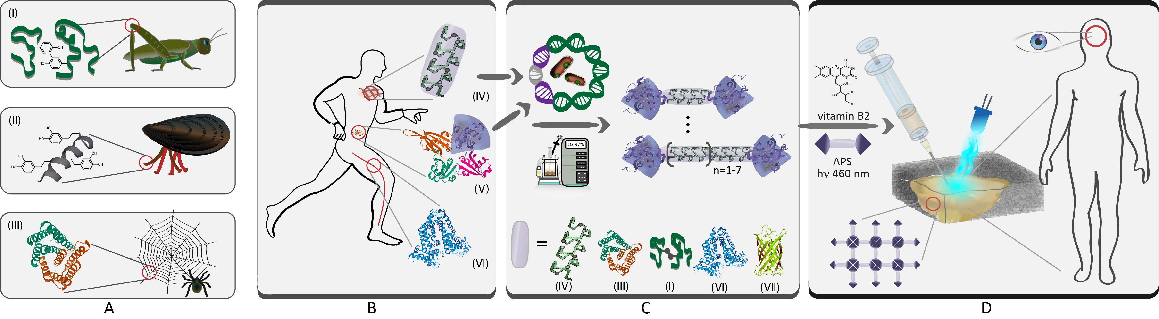

Vorschlag für eine Gliederung von Fig 1: und dann noch etwas kürzen bzw. weniger Doppelungen zu Haupttext.

**Figure 1:** Bio-inspired design principles for a protein-based bioadhesive.

**A**) Inspired by natural high-performance proteins, such as resilin (**A**, (**I**)), mussel byssus proteins (**A**, (**II**)), or spider silk and spidroin proteins (**A**, (**III**)), we aimed to create a wet-adhesive biomaterial with high mechanical strength and elasticity. **B**) Utiziling human-derived proteins, including the “ubiquitin-like domain” (ULD) from the human global gene organizer SATB1 (**B,** (**V**)), elastin-like proteins (ELP) (**B,** (**IV**)), and human serum albumin (HSA) (**B, (VI)**), we designed fusion proteins connecting two ULD domains with a protein-linker motive to fabricate **U**LD-(**L**inker Protein)-**U**LD (**ULU**) constructs. Besides ELP- and HSA-based ULU constructs (**C**, (**IV**) and (**VI**)), additional linker motives include resilin (**C**, (**I**)), spidroin (**C**, (**III**)) and green fluorescent protein (**C, (VII**)). **D**) The purified ULU is applied to wounds or tissue defects, in particular ocular defects of the cornea, and subsequently photochemically crosslinked.

# Results and Discussion

## Rational design of the hydrogel system network

The bioadhesive hydrogel system introduced here (**Figure 1**) uses a single fusion protein, composed of three building blocks: an elastic and energy dissipating protein segment (linker), and two connected, self-organizing “ubiquitin-like domains” (ULD). ULD consists of 102 amino acids (aa), comprised of 11 positively charged aa and 25 hydrophobic aa, including 9 aromatic aa. The latter are important for tissue adhesion and removal of interfacial water as described by Li et al.[14]. A BLAST homology search for the human ULD sequence (PDB 3TUO) reveals a very high conservation across species (see **SI section 2**).

It has been demonstrated previously that ULD peptides effectively form stable homo-tetramers under physiological conditions. Moreover, the crystal structure of the ULD tetramer reveals that each of the four interfaces between the subunits harbors two neighboring tyrosine residues (**Figure 2 (I)**), which can be photochemically crosslinked with catalysts such as riboflavin-5’-phosphate (riboflavin)[22] or tris(bipyridine)ruthenium(II) (ru(II)bpy)[23] , along with ammonium peroxodisulfate (APS) as an electron acceptor[23]. Consequently, the network formation was realized by a combination of physical interactions via self-assembly of the highly stable ULD protein tetramer and its (subsequent) photochemical crosslinking via natural tyrosine moieties within the ULD protein. Chemoselective tyrosine crosslinking was carried out using the photocatalysts vitamin B2/riboflavin or ru(II)bpy. It appears that only the tyrosine pairs located at the periphery of the ULD tetramer (tyrosine 81 of each ULD monomer) are accessible to bulky crosslinking catalysts (**Figure 2 (I), c**). Hence, crosslinking of tyrosine residues might predominantly rely on the distal tyrosine pairs.

Photochemical crosslinking is advantageous in the context of bioadhesion since it allows for the timely control of network formation and is suitable to restrict tissue connection to the illuminated area. Exploiting inherent tyrosine residues as crosslinking targets makes the system independent from subsequent chemical introduction of crosslinking sites (e.g., acrylates), subject to variability and calcification. Furthermore, ULD tyrosines might form covalent bonds with tyrosine residues of contiguous tissue surfaces to interconnect the protein glue tightly with these tissues.

Linker segments were N- and C-terminally combined with tetramer-forming ULD, giving ULD-(Linker protein)-ULD constructs (ULU). ULU variants have been designed as fusion proteins and cloned into expression vectors for recombinant protein synthesis. Several linker protein motives, derived from elastin, spider silk, resilin, human serum albumin (has) and green fluorescent protein (GFP), have been selected and screened for a number of factors. These included their accessibility via recombinant protein production, yield, designability (length, size and physicochemical properties), and solubility as shown in **Figures 1** and **2, as well as SI section 1**. We mainly focused on linker variants based on intrinsically disordered elastin-like proteins (ELP). ELP-linkers were genetically engineered using the One-Vector-Toolbox-Platform (OVTP) method[18]. For detailed characterization, we chose ULU variants with either 20 or 40 repeats of the ELP linker pentamer sequence Val-Pro-Gly-**Val**-Gly (VPG**V**G, short form “**V**”), e.g. ULD-**V**20-ULD and ULD-**V**40-ULD, based on their yield, purity, water solubility, and flexibility (see **SI section 3.2 and Figure S-2**). We endowed these model variants with the aa sequence Arginine (R) – Glycine (G) – Aspartic acid (D), denoted ULD-V20-RGD-ULD and ULD-V40-RGD-ULD, to promote cell adhesion.

In addition to human ELP (ULD-ELP-ULD, **Figure 2 (II)**) and serum albumin (ULD-HSA-ULD), different linker motives can be provided to combine adhesive with absorptive properties (see **SI section 1 and Table S-1**). Promising variants include ULD-spisi10/20-ULD and ULD-resi10-ULD based on fibrous and resilient linker sequences derived from spider silk spidroin and resilin, ULD-SpyCatcher-ULD containing an adapter linker sequence that can be conjugated with the short SpyTag peptide (allowing for site-selective bio-orthogonal protein functionalization), and a ULD-mEGFP-ULD construct for visualization purposes. The charged and photocrosslinkable ELP linker sequences ULD-(DSY)8-ULD and ULD-(VRY)6-ULD offer the possibility to adjust protein-tissue adhesion via hydrogel charge composition and might provide superior mechanical strength via additional Tyr-crosslinking sites. ULD-EYFP-TEVrc-mEGFP-ULD as well as ULD-EYFP-TEVrc-ULD combine fluorescent properties with network degradability via the TEVprotease recognition sequence motif (TEVrec).

## ULU building block characterization

In addition to the work reported by Wang et al.[19-20], we confirmed the absence of ULD monomers in water via SDS-PAGE, and the predominance of ULD tetramers - even at 4 M urea (**SI Figure S-3**). Complete disruption of ULD tetramers was only achieved in the presence of at least 4 M urea and 30 % ethanol. We confirmed previous findings[21] of stable ULD tetramers maintained in fusion proteins by DLS (**SI Figure S-4**).

The sequence identity of ULD-ELP-ULD proteins was confirmed using liquid chromatography mass spectrometry (LC-MS/MS) after tryptic digest (**SI section 7** and **Figure S-5**). In addition, sequence and purity of full-length intact ULD-V40-ULD and ULD-V20-ULD were confirmed by electrospray ionization (ESI-)LC-MS (**SI Figure S-6**).

## hydrogels

As previously described by Neff et. al[25], dityrosine bonds evince a characteristic blue fluorescence upon ultraviolet excitation. The blue fluorescence of a ULD-V20-ULD hydrogel is shown in **Figure 2 (IV, left sample)**, in contrast to an identical, but non-photocrosslinked ULU solution which did not show dityrosine fluorescence (**Figure 2 (IV, right sample**).

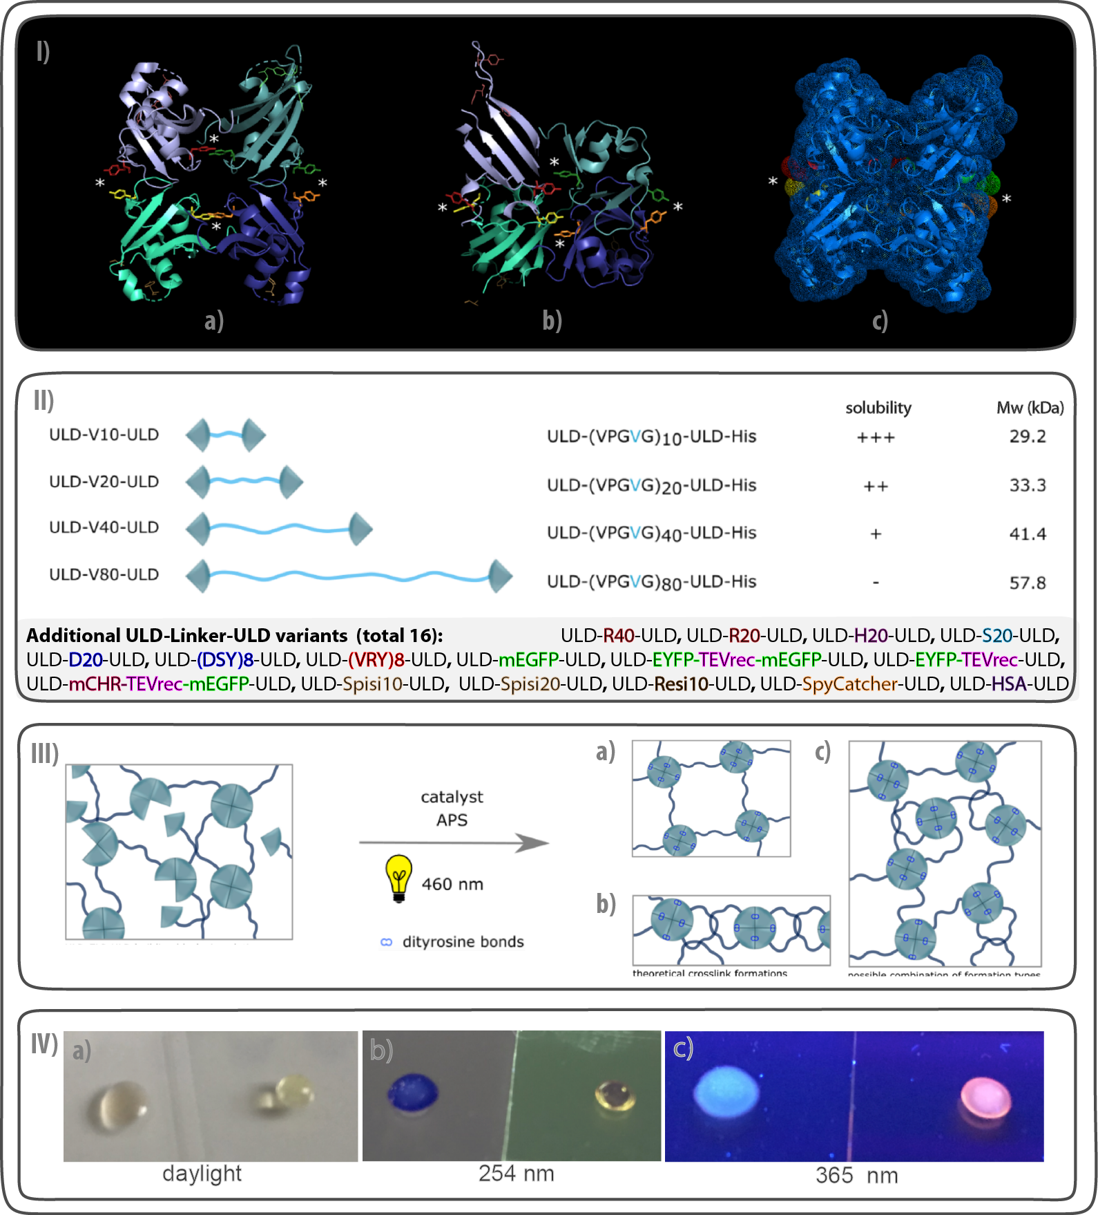

**Figure 2:** ULD-(Protein-Linker)-ULD (ULU) hydrogels represent a novel, versatile and customizable single-building-block crosslinking system. **I**) **a** and **b**) ULD tetramer crystal structure as available in the Protein Data Bank (PDB access code 3TUO) with colored tyrosine residues. **a**) tetramer front view, **b**) top view. In each of the four interfaces, two tyrosine residues are in close proximity to each other (marked by an asterisk). **c**) Water-accessible surface of the ULD tetramer (approximation via PyMol, see **SI chapter 6**). **II**) Overview of the building blocks constituting the ULU library, especially the ULD-ELP-ULD library (see **SI chapter 1** for details and sequences). **III**) Possible crosslinking arrangements of ULD-ELP-ULD building blocks include mesh wire fence-like patterns, intertwining, catenation and a combination thereof. **IV**) One of two identical non-photocrosslinked ULU solutions containing 20 % ULD-V20-ULD in water, 0.1 mM ru(II)bpy and 30 mM APS was crosslinked at 460 nm (left drop), the other was not exposed and remained liquid (right drop). The crosslinked gel drop on the left shows strong blue fluorescence upon exposure to UV light, indicating the presence of dityrosine bonds.

Semiquantitative dityrosine fluorescence measurements of riboflavin-crosslinked hydrogels revealed that the extent of dityrosine crosslink formation does not only depend on hydrogel composition, but also on the applied illumination energy density and APS concentration, illustrating that hydrogel properties can be adjusted by varying these parameters (**SI Figure S-8**).

The hydrogels were highly swollen, with a water content of approximately 80 % in hydrogels containing 20 % protein (ULD-V20-ULD, ULD-V40-ULD and ULD-V80-ULD) and 90 % water in 10 % ULD-V20-ULD hydrogels. There was no considerable difference in water content between gels crosslinked with riboflavin or with ru(II)bpy (see **SI section 10** and **Figure S-9**).

### Mechanical properties

#### Nanoindentation

To evaluate mechanical properties on a microscopic level, we determined Young’s modulus by nanoindentation utilizing the Hertz fit method[26] (**Figure 3**, for details see **SI section 11**). **Figures 3 a** and **b** demonstrate viscoelastic and creep behavior, hysteresis, and consistent courses for varying loads of up to 300 µN. For each of the hydrogel types, samples crosslinked with riboflavin exhibited slightly lower Young’s moduli, as compared to ru(II)bpy (see Figure **3 c**). Within riboflavin-crosslinked hydrogels, varying protein concentrations and, correspondingly, ELP spacer length determined hydrogel stiffness significantly. Moreover, upon crosslinking of ULD-V20-ULD and ULD-V40-ULD, using the lower energy density of 5.8 J/cm², significantly softer hydrogels were obtained, as compared to higher illumination densities (p<0.05 each). In contrast, no difference in Young’s moduli was observed between variants both with and without the RGD epitope, given both variants were equally illuminated with 5.8 J/cm².

AFM results revealed the dependence of crosslinking efficiency on the catalyst used, which was reflected by different elasticities (ULD-V20-ULD, ru(II)bpy-crosslinked: Young’s modulus 337 kPa ± 62 kPa (StD) vs. riboflavin-crosslinked: 298 kPa ± 13 kPa) and resilience values reaching up to 80 % at the mesoscopic scale (see **SI section 12** and **Table S-2**). ULD-V20-ULD and ULD-V40-ULD were chosen for further mechanical characterization and tissue sealing, based on acceptable variance of nanoindentation measurements, favorable solubility, and adhesive strength.

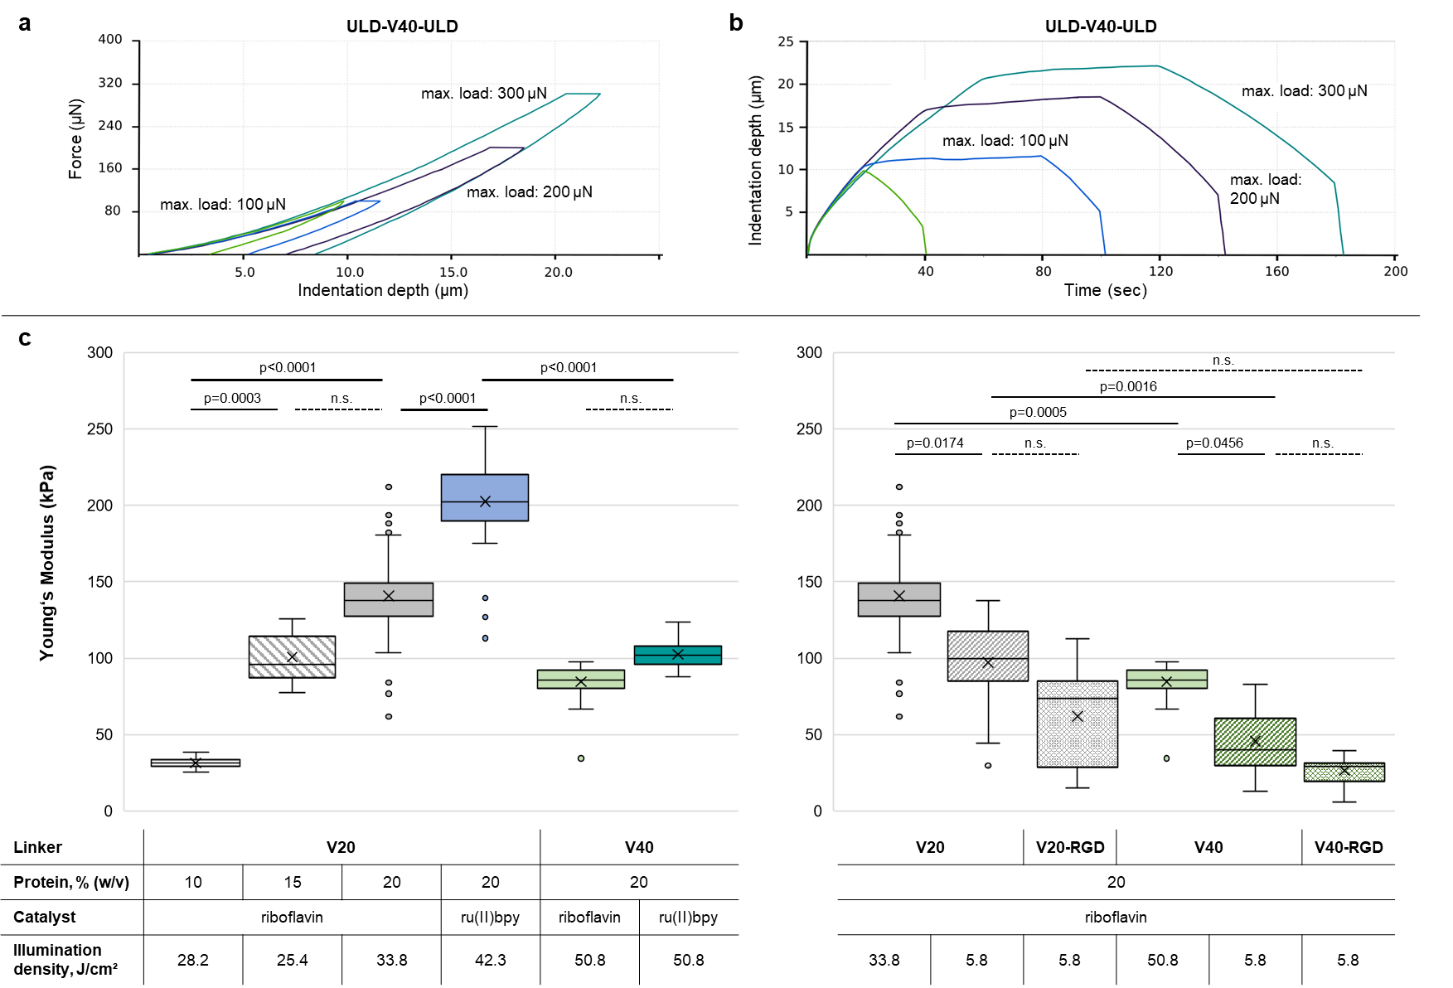

**Figure 3:** Micro-elasticity of ULU hydrogels as determined by nanoindentation. **a, b**) Exemplary force-displacement graph and displacement-time graph for various measurements of a single hydrogel pad of riboflavin-photocrosslinked ULD-V40-ULD, 20 % protein. Measurements were performed in load-controlled mode at a constant loading/unloading rate. Each curve shows a single indentation measurement. Positions of single indentations were given by a 5x3 matrix. For details, see **SI section 11**. **a**) Force-displacement curves with differing maximum loads, with or without a hold period of 60 seconds for maximum loads of 100-300 µN. **b**) Displacement-time-curves for varying maximum loads, with and without a hold period, demonstrating creep during the hold phase. **c**) Young’s moduli for ULD-V20-ULD and ULD-V40-ULD hydrogels and their RGD-containing variants ULD-V20-RGD-ULD and ULD-V40-RGD-ULD,calculated based on Hertz fit[26]. For each hydrogel type, 3-6 hydrogel pads were prepared independently and nanoindentation was performed at 15 locations on each pad.. All hydrogels were prepared in ddH2O, containing 30 mM APS, either 2.5 mM riboflavin or 0.1 mM ru(II)bpy and varying illumination density. Whiskers of the box-whisker-plots correspond to 1.5 times the interquartile range. Differences between hydrogel variants are indicated with corresponding *p*-values based on nested one-way ANOVA and Šídák’s *post-hoc* multiple comparison test. Abbr.: APS = ammonium peroxodisulfate; n.s. = not significant; RGD = amino acid sequence Arginine (R) – Glycine (G) – Aspartic acid (D); ru(II)bpy = tris(bipyridine)ruthenium(II)chloride.

In contrast to most comparable hydrogels[17, 27], our system does not exclusively depend on lowering protein or catalyst concentration - thereby altering the chemical composition - if lower gel stiffness is desired. For instance, mixing ULD-V20-ULD and ULD-V40-ULD in a 1:1 or 2:1 ratio [w/w], while maintaining the overall protein concentration of 20 %, yielded homogeneous riboflavin-crosslinked hydrogels with average Young’s moduli of 91.1 kPa (1:1 ratio; standard deviation (StD) ± 7.3 kPa) and 136.8 kPa (2:1 ratio, ± 23.1 kPa), respectively.

#### Dynamic Mechanical Analysis (DMA)

To determine bulk mechanical properties, we performed uniaxial tensile stretch experiments for riboflavin-crosslinked hydrogels of ULD-V20-ULD, ULD-V40-ULD as well as their RGD-containing variants (20 % protein each). Hydrogels for DMA experiments were prepared in 4 M urea to ensure fast and homogeneous dissolution of the high protein amount required. All hydrogels were crosslinked with 2.5 mM riboflavin, 30 mM APS and an illumination energy density of 67.7 J/cm².

Stress-strain curves for the three hydrogel types are shown in **Figure 4**. Proceeding in time, DMA measurements did not show any conclusive evidence for mechanical fatigue, as no negative trend in the calculated Young’s moduli was observable. Young’s moduli of ULD-V20-ULD and ULD-V40-ULD, as determined by DMA, ranged from 56 to 328 kPa (StD ± 32 kPa and 160 kPa) and did not differ between variants with and without the RGD epitope (p>0.05) see **Table 1**. However, a statistically significant difference between ULD-ELP-ULD variants with 20 and 40 ELP pentamer repeats was observed. Both u(UTS) strain at ULD-V20-ULD and ULD-V20-RGD-ULD demonstrated higher UTS (127.9 kPa ± 63.2 kPa and 114.0 kPa ± 69.2 kPa, respectively) compared to ULD-V40-ULD and its RGD-containing variant (80.2 kPa ± 31.7 kPa and 66.7 kPa ± 15.5 kPa). In contrast, the linker variants containing 40 ELP pentamer repeats exhibited numerically higher extensibility (up to 263% ± 46% as compared to 240 % ± 39 % for ULD-V20-ULD).

When comparing DMA results, i.e., material properties on the millimeter scale, with nanoindentation results on smaller scale, it was evident that elasticities differed, with material characteristics at both scales describing different processes within the material. Nanoindentation captures microscale protein-network deformations, mainly attributed to water redistribution within the hydrogel, as well as inhomogeneities within the hydrogel. In contrast, DMA investigates the material’s bulk behavior, while still being susceptible to local inhomogeneities, potentially leading to micro-cracks that can expand in time.

Taken together, these results describe a robust, viscoelastic hydrogel material with high tensile strength. They confirm that material stiffness can be adjusted by mixing different building blocks at a given overall protein concentration, in addition to the choice of protein spacer length. The choice of catalyst plays a role as well due to varied crosslinking efficiency (SI Table S-2). MORE EXPLANATION NEEDED!

**Figure 4:** Uniaxial tensile stretch data show robust hysteresis, high elasticity and no evidence of fatigue on a macroscopic scale.

**Table 1**: Mechanical characteristics of crosslinked ULD-V20-ULD and ULD-V40-ULD, including their RGD-containing variants, as determined by dynamic mechanical analysis (DMA).

|  |  |  |  |  |  |
| --- | --- | --- | --- | --- | --- |
|  | ULU linker type | | | | Comparison |
| V20 | V20-RGD | V40 | V40-RGD |
| Mean Young’s modulus ± StD (kPa) | 275.6 ± 152.3 | 328.4 ± 159.5 | 55.7 ± 31.7 | 91.4 ± 44.7 | V20 vs. V40: *p* = 0.0068 a  V20 vs. R40-RGD: *p* = 0.0225 a  V20-RGD vs. V40: *p* = 0.001 a  V20-RGD vs. V40-RGD:  *p* = 0.0033 a |
| Ultimate tensile strength ± StD (kPa) | 127.9 ± 63.2 | 114.0 ± 69.2 | 80.2 ± 31.7 | 66.7 ± 15.5 | *p* = 0.282 b |
| Extension to break ± StD (%) | 240.3 ± 38.5 | 188.4 ± 24.7 | 262.8 ± 46.1 | 207.3 ± 53.1 | *p*= 0.091 b |
| a one-way ANOVA, Welch test yielded p < 0.0001. Here, p-values of *post-hoc* Dunnett’s T3 multiple comparison test (comparison of all groups) are given for p < 0.05. b one-way ANOVA, Welch test  Abbr.: StD = standard deviation | | | | | |

To avoid bond failure, an optimal sealant’s modulus should match the substrate[28]. With the two presented variants ULD-V20-ULD and ULD-V40-ULD, we prepared elastic hydrogels with Young’s moduli ranging from 56 kPa to 328 kPa, UTS of 67 kPa to 128 kPa and extensibility of 188 % to 262 %, as determined by DMA (**Table 1**). In line with published findings[29], we observed that lower material stiffness was associated with higher elasticity and superior burst pressure.

Expanding the existing scope and molecular toolbox of highly elastic natural materials with >98 % resilience possible[4], the ULU bioadhesive reached a remarkable resilience of 80 %, as determined by AFM (**SI Table S-2**). Compared to this, the best commercial polymers typically exhibit a resilience between 65-87 % (from EVA (65%) and TPU (76%) to PEBAX (up to 87 %)[30].

## Sealing of corneal defects

An ophthalmological application was chosen as proof-of-concept for clinical applicability. Corneal wounds pose a particular challenge as sutures can induce scaring as well as astigmatic distortion of the corneal shape, both resulting in loss of vision. Since an ideal tissue glue for this purpose is still lacking, we addressed penetrating corneal wounds as a use case for ULU bioadhesives.

For corneal sealing experiments (**Figure 5**), we chose the non-toxic catalyst riboflavin, which is in clinical use for the crosslinking treatment of progressive keratoconus[31]. We prepared ulcer-like corneal defects or penetrating vertical incisions in de-epithelialized corneae of extracted porcine eyes (**Figure 5 c-e** top). Riboflavin-crosslinked ULD-V40-ULD and ULD-V40-RGD-ULD hydrogels (20 % protein) led to robust fillings and sealing of wet corneal defects, showing strong adherence to the corneal surface and stroma. ULU seals rather ruptured than detached from the surface once they have been crosslinked (**Figure 5 d** bottom, **SI section 14** and **Movie S-1**). Here, the ULU seal of a full-thickness incision was still stable at 100 mmHg, the maximum attainable pressure in the setup used. At intraocular pressures near 100 mmHg, liquid would rather squirt through the paracentesis than breaking the hydrogel seal (**Figure 5 f** and **SI Movie S-2**).

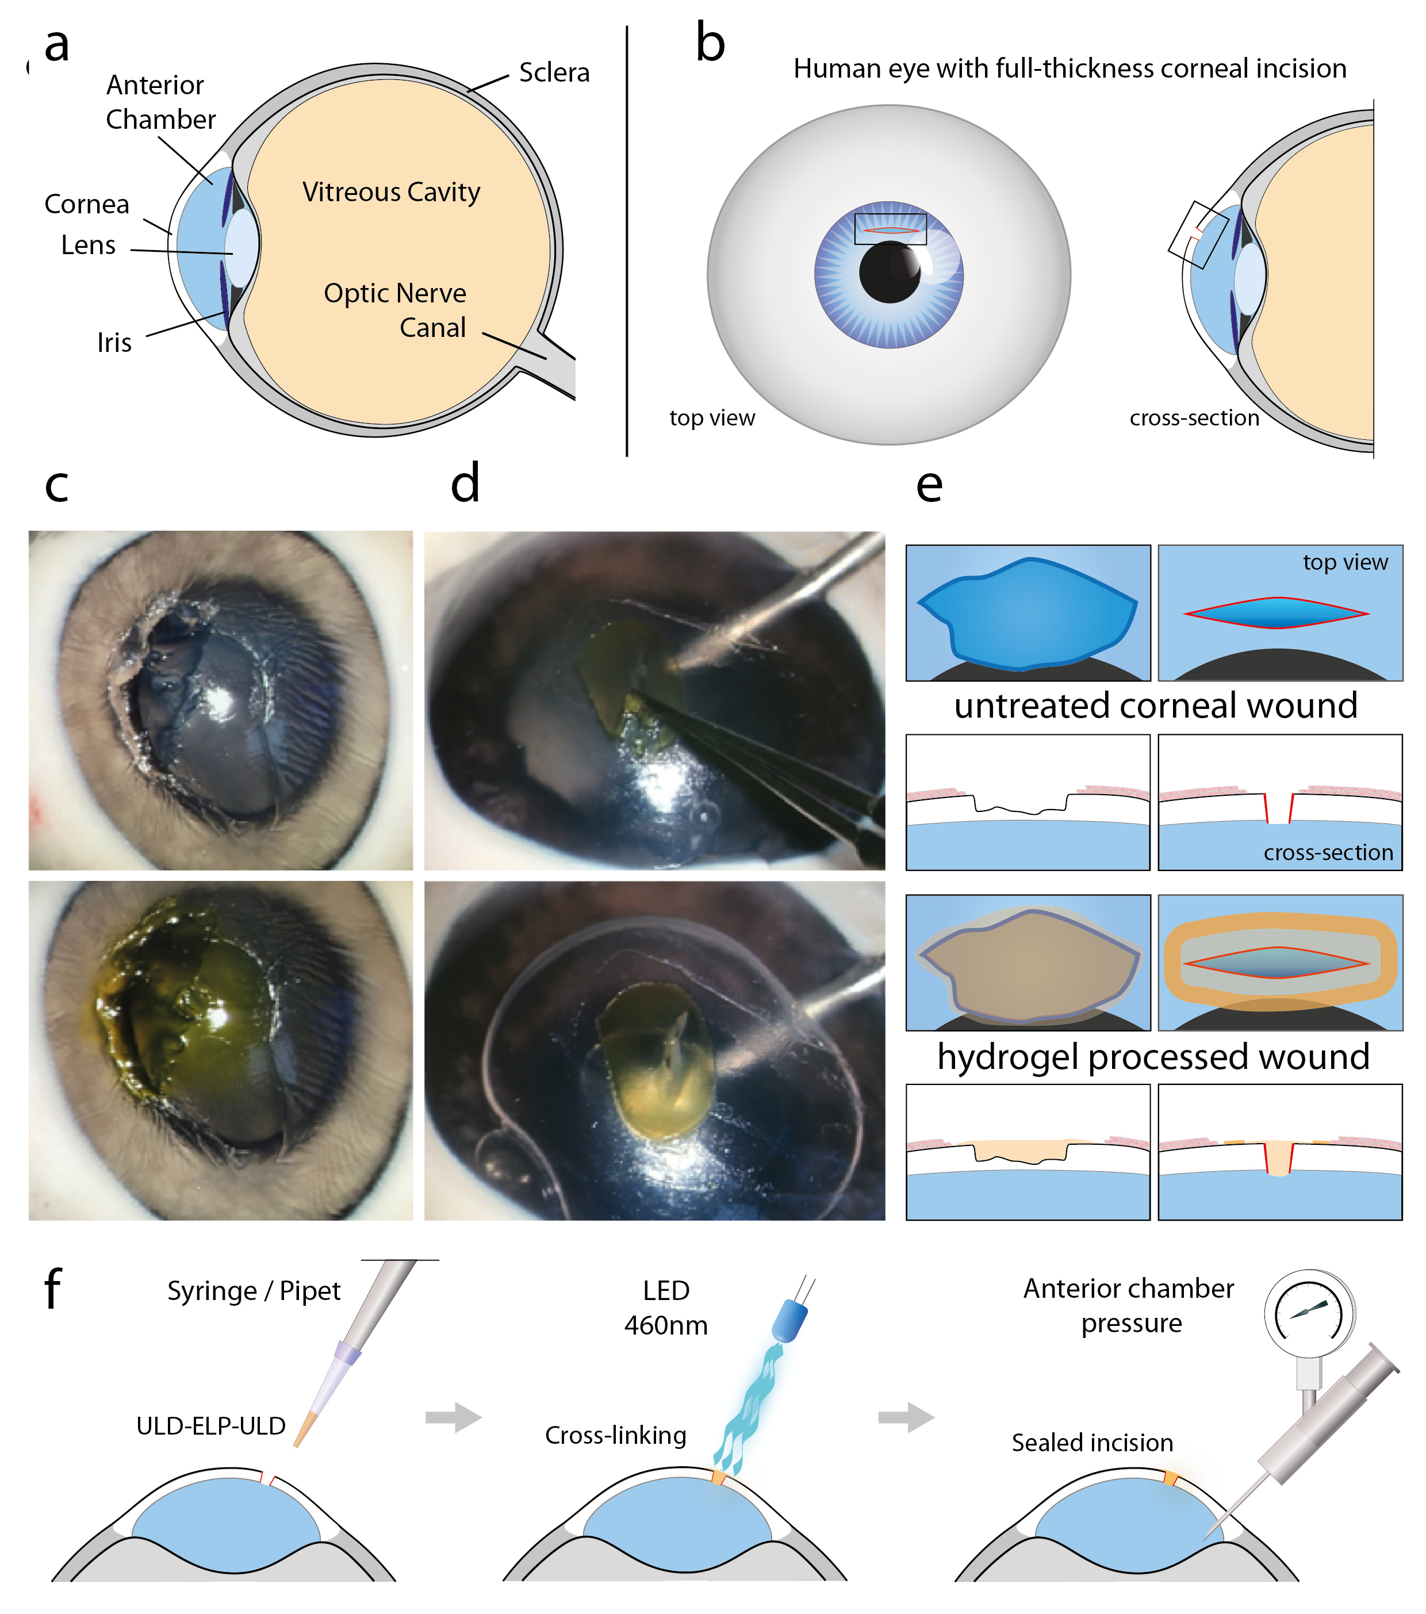

**Figure 5:** ULU hydrogels cover or seal corneal wounds effectively and demonstrate high adhesion to corneal surface. **a**) Scheme of the eye – side view. **b**) Scheme of the eye schematically visualizing a full-thickness corneal incision as experimentally treated in **d**). **c**) Eye with inflicted ulcer-like stromal wound (scheme in **e**), left column), in part de-epithelialized; top: before treatment; bottom: after filling the defect with hydrogel and photocrosslinking. LThe defect was incubated with 50 mM riboflavin for 3 minutes prior to filling it. After illumination, the defect was filled seamlessly with a strongly adhesive and mechanically stable hydrogel. **d**) Eye with inflicted full-thickness corneal incision of 2.2 mm length (scheme in e), right column). A small amount of air was injected through a paracentesis to prevent liquid from leakage. A crosslinked ULU film (the same hydrogel as used for filling and sealing defects) with a punched hole of approximately 5 mm diameter was positioned around the incision as a casting mold and filled with ULU solution which was illuminated, resulting in an adherent, crosslinked hydrogel patch. The casting mold was subsequently removed (see **Figure S-11**). Top: Crosslinked hydrogel patch sealing the full-thickness corneal incision up to intraocular pressures of 100 mmHg, both before and after removal of the air from the anterior chamber. Bottom: The patch adhered strongly to the cornea, removal of the patch with forceps resulted in tearing of the hydrogel. **e**) Schematic representation of the defects and wound/incision as treated experimentally: left – scheme of **c**), right – scheme of **d**). **f**) Scheme of the surgical sealing and wound treatment process.

Subsequently, we confirmed by histology that ULU hydrogels are bond to human cornea tissue as well. Histological sections of the paraffin-embedded glued human cornea (**Figure 6**) demonstrate that the hydrogel coalesced seamlessly with the corneal stroma. We did not observe any sign of gross cell toxicity. had ownThe hydrogel filling did not detach from the cornea up to the maximum culture duration of 7 weeks. However

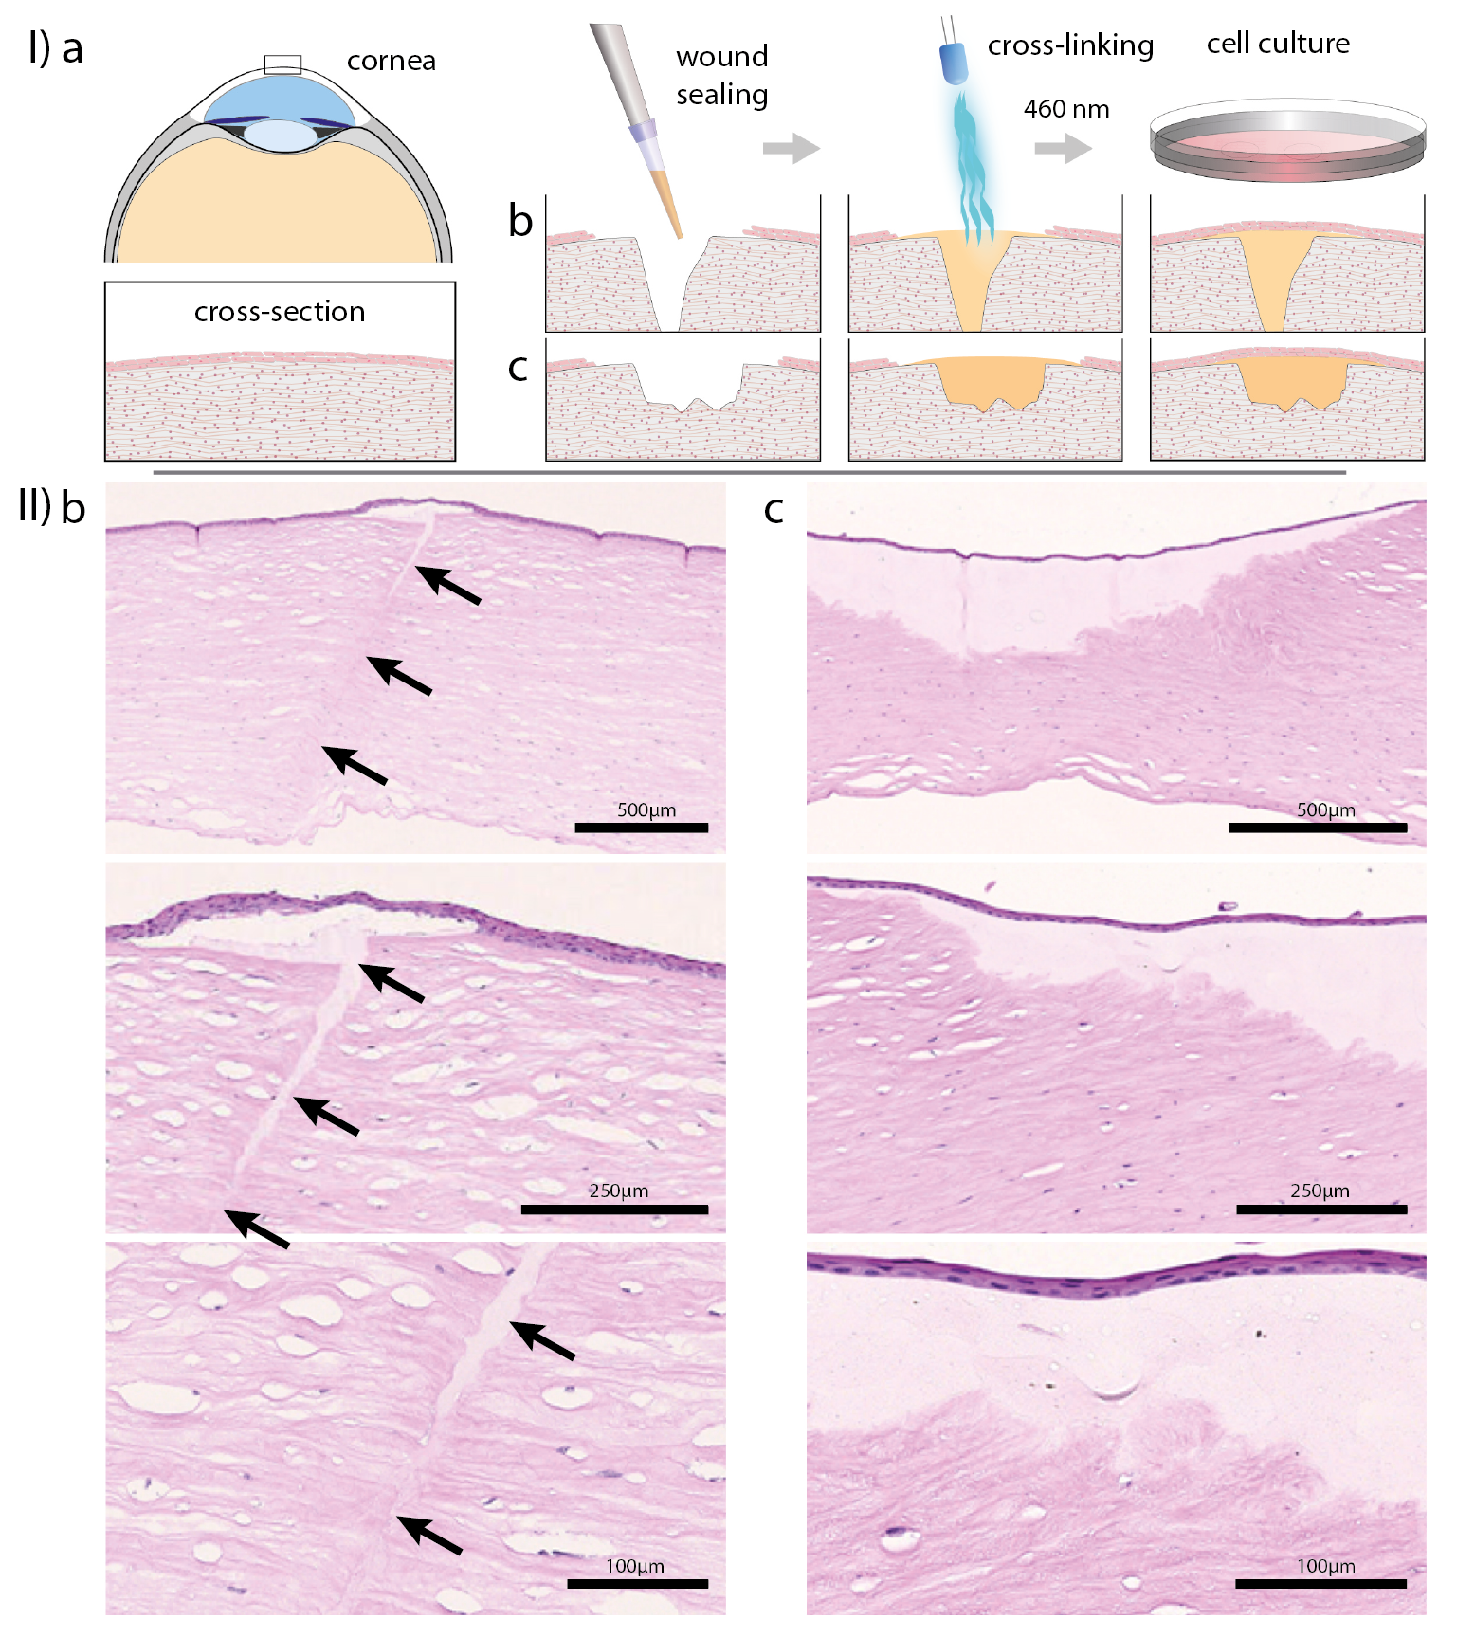

**Figure 6:** ULU hydrogels coalesced with human cornea tissue. **I**) Schematic presentation of the cross-sections shown in **II**). **I**, **a**) presentation of the position of the cross-sections depicted in **I**, **b**) and **c**). **I**, **b**) horizontal row: scheme of an incision treatment with subsequent tissue culture investigating the re-epithelialization. **I**, **c**) horizontal row: scheme of an ulcer-like corneal defect treatment with subsequent tissue culture investigating re-epithelialization. **II**) Hematoxylin-Eosin (HE)-stained paraffin-embedded human cornea explants indexed according to **I b)** and **c)** depicted in **II b)** and **II c),** respectively. A penetrating vertical incision (**II b**, vertical row of images – increasing magnification from top to bottom, arrows indicate the cutting line throughout the entire thickness of the cornea) or an ulcer-like corneal defect (**II c**, vertical row of images – increasing magnification from top to bottom) were inflicted and filled with ULD-V40-ULD, crosslinked with 2.5 mM riboflavin and 30 mM APS at 5.8 J/cm².

To test whether the connection between tissue and hydrogel was solely attributed to riboflavin instead of the ULU bioadhesive, we performed tissue attachment experiments using ru(II)bpy as a catalyst. We found that an ULD-V40-ULD hydrogel coalesced with cornea tissue comparably in the absence of riboflavin.

For corneal sealings, we applied a total exposure energy density of 5.8 J/cm², comparable to standard keratoconus treatment procedures[32], while samples for mechanical characterizations were exposed to up to 68 J/cm². However, exposure of riboflavin-crosslinked 20 % protein hydrogels of ULD-V20-ULD and ULD-V40-ULD to 5.8 J/cm² yielded slightly softer, but mechanically stable and sticky hydrogels with Young’s moduli of 97.3 kPa and 45.8 kPa (± 25.7 and 18.5 kPa), respectively, as determined by nanoindentation. These values are in a similar range as native corneal Young’s moduli determined by the same method[33]. Future research will aim at meeting the Young’s modulus other tissues by varying the ULU composition regarding protein concentration, type of catalyst, APS concentration and adapting crosslinking parameters. In combination with the linker and crosslinking conditions, the bis-ULD-functionalized ELPs provide a powerful cornea-adhesive, highly elastic, stretchable (up to 260%) and resilient (up to 80 %) surgical sealant.

Biocompatibility??? -> Reviewer reports

Strong and durable binding of bioadhesives to tissues requires adhesion to wet and dynamic surfaces - proven to be extremely challenging. It requires the synergy of an adhesive surface and a dissipative matrix,[14] involving electrostatic interactions and physical interpenetration of the molecular tissue network as well as the mechanical mechanism of energy dissipation. The charge profile of the ULD surface enables efficient electrostatic interactions and π-cation interactions contributing to its wet-adhesiveness.

The controlled photocrosslinking via riboflavin/vitamin B2 as photocatalyst avoids toxic crosslinking agents such as glutaraldehyde. By limiting the sealing processes to the illuminated area, the uncontrolled or unintended subsequential connection of biomolecules, potentially damaging tissues or creating thrombi after the gluing process, can be prevented. The crosslinking process can be controlled, e.g., by varying the intensity of blue light (460 nm) and the duration of exposure within a time window of several seconds to 3 min. The use of blue light minimizes the risk for DNA-damage and photochemical cytotoxicity known from UV-light,[34] required for the crosslinking of most advanced acrylated or methacrylated bioadhesives.[12]

# Conclusion

The ULU system, based on a human tetramer-forming ULD bisfunctionally linked to elastic, intrinsically disordered human ELP, relies on the formation of a double network: the physical self-assembly of the ULD monomer to highly stable tetramers, followed by subsequent chemoselective photocrosslinking of natural tyrosines within the ULD interaction interface forming a covalent chemical protein network. Both processes are important for a stable and long-lasting tissue interaction.

The ULU system meets essential requirements for a versatile tissue glue. It allows for a timely, controlled tissue sealing under physiological conditions. To our knowledge, this is the first purely protein-based bioadhesive system, solely comprised of recombinant human protein sequence blocks providing a pathogen-free bioadhesive with generally good biocompatibility. Due to the completely human origin of the preferred ULD-ELP-ULD system and the cross-species conservation of 98-100% for human, other mammals, birds, fish and amphibians, the ULU system does not only qualify for human medical applications but for veterinary applications as well.

With an estimated number of 4.9 million people with bilateral corneal blindness worldwide, (and an assumed prevalence of up to 23 million persons affected by unilateral corneal blindness), new, uncomplicated and reliable approaches are urgently needed for the treatment of corneal defects.[35] With riboflavin being non-toxic, well-known and approved for the treatment of progressive keratoconus[34a], our riboflavin-based crosslinking system may lay the foundation for further research in this field. We were able to tightly seal wet full-thickness central corneal incisions of 2.2 mm length in extracted porcine eyes within less than 3 minutes using low intensity light comparable to the (keratoconus treatment) at 460 nm. Such sealed incisions were able to withstand intraocular pressures (IOP) of 100 mmHg, more than 5 times the average normal intraocular pressure (IOP)[24].

Our results suggest good biocompatibility and support of endogenous tissue regeneration with regard to epithelial cells of the cornea. Beyond that, preliminary experiments with ULD-ELP-ULD hydrogels being applied to muscle (heart), vascular tissues (aorta), mucosa (stomach), parenchymatous organs (kidney) and cartilage (articular) already showed promising results for work in progress.

In addition to its adhesion to wet tissue surfaces such as cornea, our ULU system provides elasticity, transparency, easy handling, and rapid light-induced crosslinking. The green sustainable biotechnological production process of our renewable protein-based adhesives enables a feasible access to larger protein quantities at relatively low cost.

# Experimental Section/Methods

For experimental details, please refer to the Supplementary Information (SI). The DNA sequence encoding (ULD) was codon-optimized for bacterial expression and modular implementation into the One-Vector-Toolbox-Platform (OVTP)[18]. We generated a library of triblock-copolymers consisting of N- and C-terminal ULD, separated by an ELP linker domain consisting of multiples of ELP pentapeptide motifs (e.g. (VPG**X**G)n, abbreviated as **X**n) with a defined characteristic fourth amino acid (aa) (**X**). The modular cloning approach is described in detail in the SI section 1. It allows for the fast recombinant generation of an extendable library of triblock-copolymeric fusion proteins with adaptable properties mainly based on the choice of the characteristic ELP spacer domain.

The precise DNA and amino acid (aa) sequences of the in-depth analyzed fusion proteins (bold letters) are shown in **SI section 1**. Recombinantly generated fusion proteins serving as candidate protein glues with varying properties are listed in **Figure 2** and **SI Table S-1**). Based on protein production, yield, designability (length/size and physicochemical properties), solubility and biocompatibility we choose V20 and V40 as preferred linker motives.

ULD-ELP-ULD proteins were expressed in *E. coli* strain BL21(DE3) through isopropyl-β-D-thiogalactoside induction and purified by FPLC via Ni-NTA affinity chromatography followed by dialysis. Lyophilized protein aliquots were reconstituted in ddH2O water, PBS buffer or 4M urea, with either riboflavin-5’-phosphate 2.5 mM or tris(bipyridine)ruthenium(II) chloride 0.1 mM and ammonium peroxodisulfate 30 mM. This solution was chemically crosslinked by illumination at 460 nm (Prizmatix / Mountain Photonics UHP-T-DI LED). For nanoindentation with the Bioindeter, atomic force microscopy and dynamic mechanical analysis (DMA), we cast the solution between two microscopy slides and illuminated from both sides (see **SI Figure S-7**).

Dynamic light scattering (DLS) experiments were performed using a Zetasizer Nano (Malvern Instruments) and protein solutions of 2 g/L in ddH2O water or 4 M urea. Mass spectrometry was performed with intact proteins as well as tryptic peptides (LC-MS/MS) using the Agilent 1200 SL G1312B system (C18 column AdvanceBio), a time-of-flight mass spectrometer system ion trap (Bruker Daltonics) equipped with Apollo II ion funnel electrospray source and using the Data Analysis 4.2 SR2, Biotools 3.2 Peptide Editor 3.2 (Bruker Daltonics) and MASCOT 2.5 for data analysis. Semiquantitative analysis of dityrosine content in crosslinked hydrogels was performed via fluorescence spectroscopy using the SpectraMax iD5 Microplate Reader (Molecular Devices, LCC). Crosslinked hydrogels were excited at 320 nm and emission was determined at 455 nm.   
Water content of crosslinked hydrogels was determined gravimetrically for swollen and lyophilized hydrogels. Mechanical properties were investigated on both the microscopic (nanoindentation, atomic force microscopy) and macroscopic scale (DMA). Nanoindentation was performed on the Bioindenter (UNHT³ Bio, Anton Paar GmbH, Peseux) equipped with a ruby spherical tipped indenter (radius 500 µm) in load-controlled mode. Young’s moduli were analyzed by the built-in Indentation software (v7.2.6) using the Hertz fit method.

Atomic force microscopy (AFM) measurements were performed with a MFP-3D-Bio (Asylum Research, an Oxford Instruments Company, Santa Barbara, USA) in ultrapure water (18.2 MΩ cm, Purelab Chorus 1, Elga LabWater, Celle, Germany) using a biosphere B1000-NCH (40.000 N/m) cantilever (nanotools GmbH, München, Germany) and a spherical tip with a radius of 1 µm consisting of diamond like carbon (DLC). For obtaining the Young’s modulus, force maps (a grid of 10 x 10 points covering an area of 10 µm x 10 µm) were taken on different spots of the respective sample applying the Hertz model[37] to the indentation curve (approach part). The resilience was determined by calculating the ratio of the areas under the approach (indentation portion) and retraction curve as described in H. G. Huson & J. M. Maxwell[38] (**SI Table S-2**).

Uniaxial tensile stretch experiments (DMA) were carried out in PBS buffer at 37 °C with the incubator-housed ElectroForce 5210 BioDynamic-Test-System (Texas Instruments, Dallas, Texas, USA; formerly Bose, Minnesota, USA) used in[39]. Each sample underwent uniaxial tensile stretching with maximum displacement of 20 % at a frequency of 0.1 Hz to 1 Hz. Subsequently, samples were stretched until rupture, yielding the ultimate tensile strength and extension to break. DMA data were processed using python 3.6.6 with the standard numpy.fft and scipy.signal packages. Data sets from periodical stretching were split into 4 subsets of equal length. Noise was removed by extracting the corresponding discrete frequency spectra via fast Fourier transform, masking spectral parts connected to both low and high frequency noise, and transforming back into time domain. We calculated the Young’s moduli based on the slope of a line connecting the points of minimum and maximum stress-strain of each subgroup’s elliptical hysteresis plot. For stretch to rupture measurements, we applied a first-order Savitzky-Golay filter to smoothen measured force data and subsequently extracted the conserved extrema of interest to obtain ultimate tensile strength and strain (= extension to break).   
Statistical analyses were performed using GraphPad Prism v9.2.0 or higher. Nanoindentation data were analyzed via nested one-way ANOVA and Šídák’s post-hoc multiple comparison test. DMA data were analyzed via one-way ANOVA employing a Welch test and Dunnett’s T3 post-hoc multiple comparison test.

For cornea sealing experiments, the cornea of whole porcine eyes obtained from a local abattoir was either perforated or lamellar defects were introduced with a scalpel. In perforated eyes, a small amount of air was injected into the anterior chamber as done clinically to avoid excess leakage of fluid. An intraocular pressure sensor (Geuder, Heidelberg, Germany) was installed to assess leakage pressure thresholds. For cell culture experiments, human donor cornea material was provided by the Lions Cornea Bank Baden-Württemberg (Freiburg, Germany) if research use had been consented by the donor or the next of kin. Ethics approval has been granted by the local Ethics Committee (Research Ethics Committee of University of Freiburg). The human corneae were mounted on an artificial anterior eye chamber (Katena Products, Denville, NJ, U.S.A.). A superficial lamellar defect or a penetrating stab incision were induced and sealed with 2-4 µL of ULU solution (ULD-V20/40-ULD plus photocatalyst and APS) and subsequent photocrosslinking with total exposure energy density of 5.8 J/cm² at 460 nm). Subsequently, the corneae were cultivated up to 7 weeks and processed to obtain paraffin sections, which were stained with Hematoxylin-eosin(HE) to visualize the hydrogel filling and cells.

**Supporting Information**

Supporting Information is available from the Wiley Online Library or from the author.

**Acknowledgments**

We thank Jürgen Beck and the Eye Center staff for their great support. We gratefully acknowledge the support of the BMBF (31A490 and Research Prize Next Generation of Biotechnological Processes 2014 Biotechnology2020+, 031A550), the Baden-Württemberg Stiftung, the Zentrum für Biosystem Analyse (ZBSA), the Freiburg Institute for Advanced Studies (FRIAS), the institute for macromolecular chemistry, the Institute for Micro System Engineering (IMTEK), the Deutsche Forschungsgemeinschaft (DFG, German Research Foundation) under Germany’s Excellence Strategy – EXC-2193/1 – 390951807 and EXC 294 BIOSS Centre for Biological Signalling Studies and the Rectorate of the University of Freiburg for support.

Received: ((will be filled in by the editorial staff))  
Revised: ((will be filled in by the editorial staff))  
Published online: ((will be filled in by the editorial staff))

**Conflict of interests**

The authors Anna Resch, Matthias C. Huber and Stefan M. Schiller are inventors on a related patent application.

Author contributions

SMS proposed the project. AnR, MCH, AlR, AS, TL, UJ, AK, MT, BNB and SH performed the experiments and data analysis. SMS and GS coordinated the project. All authors discussed the results and contributed to the preparation of the paper.

ORCID:

Matthias C. Huber: 0000-0003-3034-793X

Stefan M. Schiller: 0000-0001-6864-496X

# References

[1] a) F. Vollrath, W. J. Fairbrother, R. J. P. Williams, E. K. Tillinghast, D. T. Bernstein, K. S. Gallagher, M. A. Townley, *Nature* **1990**, *345*, 526–528; b) V. Sahni, T. Blackledge, A. Dhinojwala, *Nat Commun* **2010**, *1*.

[2] J. Yu, Y. Kan, M. Rapp, E. Danner, W. Wei, S. Das, D. R. Miller, Y. Chen, J. H. Waite, J. N. Israelachvili, *Proc Natl Acad Sci U S A.* **2013**, *110*, 15680–15685.

[3] J. Gosline, M. Lillie, E. Carrington, P. Guerette, C. Ortlepp, K. Savage, *Philos Trans R Soc Lond B Biol Sci.* **2002**, *357*, 121–132.

[4] C. M. Elvin, A. G. Carr, M. G. Huson, J. M. Maxwell, R. D. Pearson, T. Vuocolo, N. E. Liyou, D. C. C. C. Wong, D. J. Merritt, N. E. Dixon, *Nature* **2005**, *437*, 999-1002.

[5] N. Saha, N. Saha, T. Sáha, E. T. Öner, U. V. Brodnjak, H. Redl, J. von Byern, P. Sáha, *Polymers* **2020**, *12*, 3015.

[6] R. Jain, S. Wairkar, *International Journal of Biological Macromolecules* **2019**, *137*, 95–106.

[7] G. M. Taboada, K. Yang, M. J. N. Pereira, S. S. Liu, Y. Hu, J. M. Karp, N. Artzi, Y. Lee, *Nature Review Materials* **2020**, *5*, 310-329.

[8] L. Ge, S. Chen, *Polymers* **2020**, *12*, 939-939.

[9] a) A. P. Duarte, J. F. Coelho, J. C. Bordado, M. T. Cidade, M. H. Gil, *Progress in Polymer Science* **2012**, *37*, 1031-1050; b) H. C. Park, R. Champakalakshmi, P. P. Panengad, M. Raghunath, J. S. Mehta, *Expert Review of Ophthalmology* **2011**, *6*, 631-655.

[10] W. B. Fürst, Asmita, *The Annals of Thoracic Surgery* **2004**, *79*, 1522-1528.

[11] A. W. S. Erasmi, H.H.; Wolschläger, C. , *Ann Thorac Surg.* **2002**, *73*, 1025-1026.

[12] a) D.-A. Wang, S. Varghese, B. Sharma, I. Strehin, S. Fermanian, J. Gorham, D. H. Fairbrother, B. M. Cascio, J. H. Elisseeff, *Nature Materials* **2007**, *6*, 385-392; b) N. Annabi, Y.-N. Zhang, A. Assmann, E. S. Sani, G. Cheng, A. D. Lassaletta, A. Vegh, B. Dehghani, G. U. Ruiz-Esparza, X. Wang, S. Gangadharan, A. S. Weiss, A. Khademhosseini, *Science Translational Medicine* **2017**, *9*, eaai7466; c) E. Shirzaei Sani, A. Kheirkhah, D. Rana, Z. Sun, W. Foulsham, A. Sheikhi, A. Khademhosseini, R. Dana, N. Annab, *Science Advances* **2019**, *5*, eaav1281; d) Y. Hong, F. Zhou, Y. Hua, X. Zhang, C. Ni, D. Pan, Y. Zhang, D. Jiang, L. Yang, Q. Lin, Y. Zou, D. Yu, D. E. Arnot, X. Zou, L. Zhu, S. Zhang, H. Ouyang, *Nature Communications* **2019**, *10*, 2060.

[13] C. Frick, A. Dietz, K. Merritt, T. H. Umbreit, V. J. Tomazic-Jezic, *Journal of Long-Term Effects of Medical Implants* **2006**, *16*, 423-433.

[14] J. Li, A. D. Celiz, J. Yang, Q. Yang, I. Wamala, W. Whyte, B. R. Seo, N. V. Vasilyev, J. J. Vlassak, Z. Suo, D. J. Mooney, *Science* **2017**, *357*, 378-381.

[15] aH. Schellekens, W. E. Hennink, V. Brinks, *Pharm Res* **2013**, *30*, 1729-1734; bW. Wei, Y. Ma, X. Yao, W. Zhou, X. Wang, C. Li, J. Lin, Q. He, S. Leptihn, H. Ouyang, *Bioactive Materials* **2021**, *6*, 998–1011.

[16] G. Trujillo-de Santiago, R. Sharifi, K. Yue, E. S. Sani, S. S. Kashaf, M. M. Alvarez, J. Leijten, A. Khademhosseini, R. Dana, N. Annabi, *Biomaterials* **2019**, *197*, 345-367.

[17] K. J. Lampe, A. L. Antaris, S. C. Heilshorn, *Acta Biomaterialia* **2013**, *9*, 5590-5599.

[18] M. C. Huber, A. Schreiber, W. Wild, K. Benz, S. M. Schiller, *Biomaterials* **2014**, *35*, 8767-8779.

[19] Z. Wang, X. Yang, X. Chu, J. Zhang, H. Zhou, Y. Shen, J. Long, *Nucleic Acids Research* **2012**, *40*, 4193-4202.

[20] Z. Wang, X. Yang, S. Guo, Y. Yang, X. C. Su, Y. Shen, J. Long, *Journal of Biological Chemistry* **2014**, *289*, 27376-27385.

[21] X. Zhang, X. Chu, L. Wang, H. Wang, G. Liang, J. Zhang, J. Long, Z. Yang, *Angewandte Chemie - International Edition* **2012**, *51*, 4388-4392.

[22] R. Kanwar, D. Balasubramanian, *Biochemistry* **2000**, *39*, 14976-14983.

[23] D. A. Fancy, T. Kodadek, *Proceedings of the National Academy of Sciences of the United States of America* **1999**, *96*, 6020-6024.

[24] Coleman DJ, T. S., *Arch Ophthalmol.* **1969**, *82*, 637-640.

[25] D. Neff, S. F. Frazier, L. Quimby, R. T. Wang, S. Zill, *Arthropod Structure and Development* **2000**, *29*, 75-83.

[26] H. Hertz, *Journal für die reine und angewandte Mathematik* **1881**, *171*, 156-171.

[27] a) C. M. Madl, L. M. Katz, S. C. Heilshorn, *Advanced Functional Materials* **2016**, *26*, 3612-3620; b) Y. N. Zhang, R. K. Avery, Q. Vallmajo-Martin, A. Assmann, A. Vegh, A. Memic, B. D. Olsen, N. Annabi, A. Khademhosseini, *Advanced Functional Materials* **2015**, *25*, 4814-4826; c) M. J. Glassman, R. K. Avery, A. Khademhosseini, B. D. Olsen, *Biomacromolecules* **2016**, *17*, 415-426.

[28] C. W. Peak, J. J. Wilker, G. Schmidt, *Colloid and Polymer Science* **2013**, *291*, 2031-2047.

[29] A. W. Martinez, J. M. Caves, S. Ravi, W. Li, E. L. Chaikof, *Acta Biomaterialia* **2014**, *10*, 26-33.

[30] G. T. Burns, N. Tam, *British Journal of Sports Medicine* **2020**, *54*, 439-440.

[31] G. Wollensak, *Current Opinion in Ophthalmology* **2006**, *17*, 356-360.

[32] G. Wollensak, E. Spoerl, T. Seiler, *Am J Ophthalmol* **2003**, *135*, 620-627.

[33] M. V. Swain, J. Nohava, P. Eberwein, *Acta Biomaterialia* **2017**, *50*, 312-321.

[34] a) M. W. Belin, L. Lim, R. K. Rajpal, F. Hafezi, J. A. P. Gomes, B. Cochener, *Cornea* **2018**, *37*, 1218-1225; b) R. P. Sinha, D.-P. Häder, *Photochemical & Photobiological Sciences* **2002**, *1*, 225-236.

[35] M. S. Oliva, T. Schottman, M. Gulati, *Indian Journal of Ophthalmology* **2012**, *60*, 423-427.

[36] D. W. Urry, T. Hugel, M. Seitz, H. E. Gaub, L. Sheiba, J. Dea, J. Xu, T. Parker, *Philosophical Transactions of the Royal Society B: Biological Sciences* **2002**, *357*, 169-184.

[37] F. Rico, P. Roca-Cusachs, N. Gavara, R. Farré, M. Rotger, D. Navajas, *Physical Review E* **2005**, *72*, 021914.

[38] M. G. Huson, J. M. Maxwell, *Polymer Testing* **2006**, *25*, 2-11.

[39] a) M. Rothdiener, M. Hegemann, T. Uynuk-Ool, B. Walters, P. Papugy, P. Nguyen, V. Claus, T. Seeger, U. Stoeckle, K. A. Boehme, W. K. Aicher, J. P. Stegemann, M. L. Hart, B. Kurz, G. Klein, B. Rolauffs, *Scientific Reports* **2016**, *6*, 1-15; b) B. Walters, T. Uynuk-Ool, M. Rothdiener, J. Palm, M. L. Hart, J. P. Stegemann, B. Rolauffs, *Scientific Reports* **2017**, *7*, 1-14.